|  |  |  |  |
| --- | --- | --- | --- |
| **STANDARD FORM 299**  **APPLICATION FOR TRANSPORTATION, UTILITY SYSTEMS, TELECOMMUNICATIONS AND FACILITIES**  **ON FEDERAL LANDS AND PROPERTY** | | | FORM APPROVED  OMB Control Number: 0596-0249  Expiration Date: 02/28/2023 |
| FOR AGENCY USE ONLY |
| NOTE: Before completing and filing the application for an authorization (easement, right-of-way, lease, license or permit), the applicant should completely review this package, including instructions, and schedule a pre-application meeting with representatives of the agency responsible for processing the application. Each agency may have specific and unique requirements to be met in preparing and processing the application. Many times, with the help of the agency representative, the application can be completed at the pre-application meeting. | | | Application Number |
| Date Filed  3/29/2024 |
| 1. Name and address of applicant   Weber County Sheriff’s Office  1400 Depot Drive  Ogden Utah 84414 | | 2. Name and address of authorized agent if different from item 1  Commissioner Sharon Bolos  2380 Washington Blvd.  Ogden Utah 84401 | 3. Applicant telephone number and email:  801-778-6914  mhorton@webercountyutah.gov |
| Authorized agent telephone number and email:  sbolos@webercountyutah.gov  801-399-8406 |
| 4. As applicant are you? *(check one)*   1. Individual 2. Corporation* 3. Partnership/Association* 4. State Government/State Agency 5. Local Government 6. Federal Agency   *\* If checked, complete supplemental page* | 5. Specify what application is for: *(check one)*   1. New authorization 2. Renewing existing authorization number 3. Amend existing authorization number 4. Assign existing authorization number 5. Existing use for which no authorization has been received * 6. Other*   *\* If checked, provide details under item 7* | | |

1. If an individual, or partnership, are you a citizen(s) of the United States? Yes No



1. Project description (describe in detail): (a) Type of use or occupancy, *(e.g., canal, pipeline, road, telecommunications);* (b) related structures and facilities; (c) physical specifications *(Length, width, grading, etc.*); (d) term of days/years needed: (e) time of year of use or operation; (f) Volume or amount of product to be transported; (g) duration and timing of construction; and (h) temporary work areas needed for activity/construction *(Attach additional sheets, if additional space is needed.)*  *(a).Radio Communications (b) Building and radio tower (c)n/a (d) 365 days and maximum allowed years allotted for operation (e) all times of year for operation (f)n/a (g)n/a (h)n/a*

8.

Attach a

map covering area and

show

location of project

proposal

.

9

. State or Local

government

approval:

Attached

Appli

ied for

Not

Required

10

. Nonrefundable

application

fee:

Attached

Not

required

To be determined by agency

Yes

No

*(*

*if*

*"yes," indicate*

*on*

*map)*

11. Does project cross international boundary or affect international waterways? No

12. Give statement of your technical and financial capability to construct, operate, maintain, and terminate system for which authorization is being requested. n/a

13a. Describe other alternative locations considered. n/a

1. Why were these alternatives not selected? This is a renewal application
2. Give explanation as to why it is necessary to use or occupy Federal assets (lands or buildings). Location is a radio tower and building used by Law Enforcement and agencies for communications.
3. List authorizations and pending applications filed for similar projects which may provide information to the authorizing agency. *(Specify number, date, code, or name) n/a*
4. Provide statement of need for project, including the economic feasibility and items such as: (a) cost of proposal (construction, operation, and maintenance); (b) estimated cost of next best alternative; and (c) expected public benefits.
5. Describe probable effects on the population in the area, including the social and economic aspects, and the rural lifestyles. Used for emergency communications
6. Describe likely environmental effects that the proposed project will have on: (a) air quality; (b) visual impact; (c) surface and ground water quality and quantity; (d) the control or structural change on any stream or other body of water; (e) existing noise levels; and (f) the surface of the land, including vegetation, permafrost, soil, and soil stability; and, (g) historic or archaeological resources or properties. n/a
7. Describe the probable effects that the proposed project will have on (a) populations of fish, plant life, wildlife, and marine life, including threatened and endangered species; and (b) marine mammals, including hunting, capturing, collecting, or killing these animals. n/a
8. State whether any hazardous material, as defined in this paragraph, would be used, produced, transported or stored on or in a federal building or federal lands or would be used in connection with the proposed use or occupancy. “Hazardous material” shall mean (a) any hazardous substance under section 101(14) of the

Comprehensive Environmental Response, Compensation, and Liability Act (CERCLA), 42 U.S.C. § 9601(14); (b) any pollutant or contaminant under section 101(33) of CERCLA, 42 U.S.C. § 9601(33); (c) any petroleum product or its derivative, including fuel oil, and waste oils; and (d) any hazardous substance, extremely hazardous substance, toxic substance, hazardous waste, ignitable, reactive or corrosive materials, pollutant, contaminant, element, compound, mixture, solution or substance that may pose a present or potential hazard to human health or the environment under any applicable environmental laws. The holder shall not store any hazardous materials at the site without prior written approval from the authorized officer. This approval shall not be unreasonably withheld. If the authorized officer provides approval, this permit shall include (or in the case of approval provided after this permit is issued, shall be amended to include) specific terms addressing the storage of hazardous materials, including the specific type of materials to be stored, the volume, the type of storage, and a spill plan. Such terms shall be proposed by the holder and are subject to approval by the authorized officer. none

1. Name all the Federal Department(s)/Agency(ies) where this application is being filed. Utah Division of Natural Resources

I HEREBY CERTIFY, That I am of legal age and authorized to do business in the State and that I have personally examined the information contained in the application and believe that the information submitted is correct to the best of my knowledge.

Signature of Applicant Date

Title 18, U.S.C. Section 1001, makes it a crime for any person knowingly and willfully to make to any department or agency of the United States any false, fictitious, or fraudulent statements or representations as to any matter within its jurisdiction.

GENERAL INFORMATION

# *ALASKA NATIONAL INTEREST LANDS*

This application will be used when applying for a right-of-way, permit, license, lease, or certificate for the use of Federal lands which lie within conservation system units and National Recreation or Conservation Areas as defined in the Alaska National Interest lands Conservation Act. Conservation system units include the National Park System, National

Wildlife Refuge System, National Wild and Scenic Rivers System, National Trails System, National Wilderness Preservation System, and National Forest Monuments.

Transportation utility systems telecommunication installations facility uses for which the application may be used are:

1. Canals, ditches, flumes, laterals, pipes, pipelines, tunnels, and other systems for the transportation of water.
2. Pipelines and other systems for the transportation of liquids other than water, including oil, natural gas, synthetic liquid and gaseous fuels, and any refined product produced therefrom.
3. Pipelines, slurry and emulsion systems, and conveyor belts for transportation of solid materials.
4. Systems for the transmission and distribution of electric energy.
5. Wired and wireless systems for transmission or reception of radio, television, telephone, telegraph, and other electronic signals, and other means of communications.
6. Improved right-of-way for snow machines, air cushion vehicles, and all- terrain vehicles.
7. Roads, highways, railroads, tunnels, tramways, airports, landing strips, docks, and other systems of general transportation.

This application must be filed simultaneously with each Federal department or agency requiring authorization to establish and operate your proposal.

In Alaska, the following agencies will help the applicant file an application and identify the other agencies the applicant should contact and possibly file with:

Department of Agriculture

Regional Forester, Forest Service (USFS)

P.O. Box 21628

Juneau, Alaska 99802-1628

Telephone: (907) 586-7847 *(or a local Forest Service Office)*

Department of the Interior

Bureau of Indian Affairs (BIA)

Alaska Regional Office

709 West 9th Street

Juneau, Alaska 99802

Telephone: (907) 586-7177

Department of the Interior

Alaska State Office

Bureau of Land Management

222 West 7th Avenue #13

Anchorage, Alaska 99513

Public Room: 907-271-5960

FAX: 907-271-3684

*(or a local BLM Office)*

U.S. Fish & Wildlife Service (FWS) National Park Service (NPS)

Office of the Regional Director 1011 Alaska Regional Office

East Tudor Road Anchorage, Alaska 240 West 5th Avenue

99503 Telephone: (907) 786-3440 Anchorage, Alaska 99501

Telephone: (907) 644-3510

Note - Filings with any Interior agency may be filed with any office noted above or with the Office of the Secretary of the Interior, Regional Environmental Officer, P.O. Box 120, 1675 C Street, Anchorage, Alaska 99513.

Department of Transportation

Federal Aviation Administration

Alaska Region AAL-4, 222 West 7th Ave., Box 14

Anchorage, Alaska 99513-7587 Telephone: (907) 271-5285

NOTE - The Department of Transportation has established the above central filing point for agencies within that Department. Affected agencies are: Federal Aviation Administration (FAA), Coast Guard (USCG), Federal Highway Administration (FHWA), Federal Railroad Administration (FRA).

OTHER THAN ALASKA NATIONAL INTEREST LANDS

Use of this form is not limited to National Interest Conservation Lands of Alaska.

Individual department/agencies may authorize the use of this form by applicants for transportation, utility systems, telecommunication installations and facilities on other Federal lands outside those areas described above.

For proposals located outside of Alaska, applications will be filed at the local agency office or at a location specified by the responsible Federal agency.

SPECIFIC INSTRUCTIONS

# *(Items not listed are self-explanatory)*

1. Attach preliminary site and facility construction plans. The responsible agency will provide instructions whenever specific plans are required.
2. Generally, the map must show the section(s), township(s), and range(s) within which the project is to be located. Show the proposed location of the project on the map as accurately as possible. Some agencies require detailed survey maps. The responsible agency will provide additional instructions.

9, 10, and 12 The responsible agency will provide additional instructions.

1. Providing information on alternate locations in as much detail as possible, discussing why certain locations were rejected and why it is necessary to use Federal assets will assist the agency(ies) in processing your application and reaching a final decision. Include only reasonable alternate locations as related to current technology and economics.
2. The responsible agency will provide instructions.
3. Generally, a simple statement of the purpose of the proposal will be sufficient. However, major proposals located in critical or sensitive areas may require a full analysis with additional specific information. The responsible agency will provide additional instructions.
4. through 19 Providing this information with as much detail as possible will assist the Federal agency(ies) in processing the application and reaching a decision. When completing these items, you should use a sound judgment in furnishing relevant information. For example, if the project is not near a stream or other body of water, do not address this subject. The responsible agency will provide additionalinstructions.

Application must be signed by the applicant or applicant's authorized representative.

**EFFECT OF NOT PROVIDING INFORMATION**

Disclosure of the information is voluntary. If all the information is not provided, the proposal or application may be rejected.

# DATA COLLECTION STATEMENT

The Federal agencies collect this information from proponents and applicants requesting a right-of-way, permit, license, lease, or certification for use of Federal assets. The Federal agencies use this information to evaluate a proponent’s or applicant’s proposal to use Federal assets.

# BURDEN STATEMENT

According to the Paperwork Reduction Act of 1995, an agency may not conduct or sponsor, and a person is not required to respond to a collection of information unless it displays a valid OMB control number. The valid OMB control number for this information collection is 0596-0249. The time required to complete this information collection is estimated to average 8 hours per response, including the time for reviewing instructions, searching existing data sources, gathering and maintaining the data needed, and completing and reviewing the collection of information. The authority to collect this information is derived from 47 U.S.C. 1455(c)(3) and 16 U.S.C. 3210.

**USDA NONDISCRIMNATION STATEMENT**

The U.S. Department of Agriculture (USDA) prohibits discrimination in all its programs and activities on the basis of race, color, national origin, age, disability, and where applicable, sex, marital status, familial status, parental status, religion, sexual orientation, genetic information, political beliefs, reprisal, or because all or part of an individual’s income is derived from any public assistance. (Not all prohibited bases apply to all programs.) Persons with disabilities who require alternative means for communication of program information (Braille, large print, audiotape, etc.) should contact USDA’s TARGET Center at 202-720-2600 (voice and TDD).

To file a complaint of discrimination, write USDA, Director, Office of Civil Rights, 1400 Independence Avenue, SW, Washington, DC 20250-9410 or call toll free (866) 632-9992 (voice). TDD users can contact USDA through local relay or the Federal relay at (800) 877-8339 (TDD) or (866) 377-8642 (relay voice). USDA is an equal opportunity provider and employer.

The Privacy Act of 1974 (5 U.S.C. 552a) and the Freedom of Information Act (5 U.S.C. 552) govern the confidentiality to be provided for information received by the Forest Service.

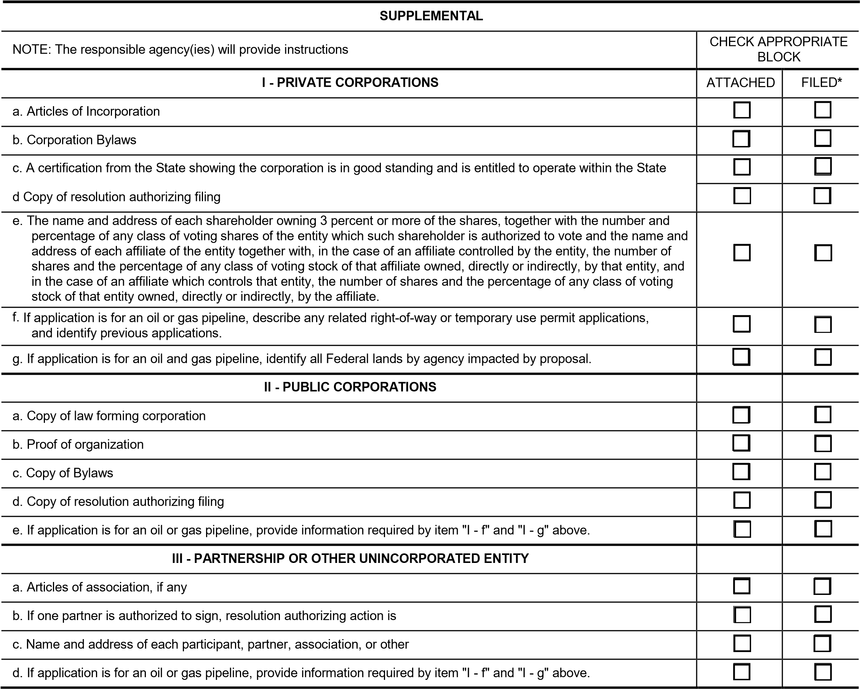

**\***If the required information is already filed with the agency processing this application and is current, check block entitled "Filed." Provide the file identification information *(e.g., number, date, code, name)*. If not on file or current, attach the requested information.